Name: ________________________________Date: ___________________________________

Class: _________________________________Teacher: ___________________________________

# Applications of Quadratics

### Warm-up

Your friend takes a video of you dropping a tennis ball from about 4m (12 ft) high. Using Python, you analyze the video and calculate the height of the ball from the ground versus time. The graph is below.

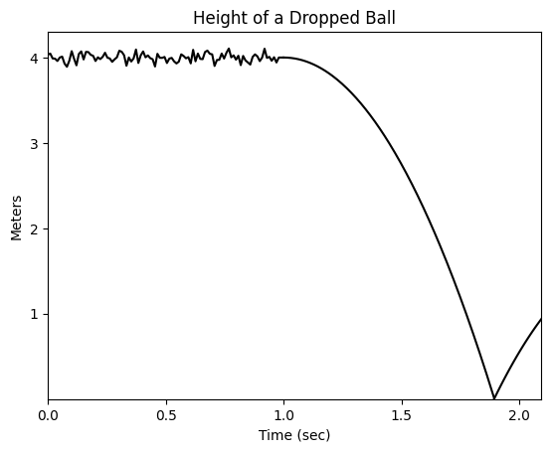

Using the graph, at what time do you think each of the following happened? Why?

1. the ball is dropped
2. when the ball hits the ground
3. When the ball is moving the fastest

### Chucking a Ball

Your friend takes another video, this time of you throwing the ball on the football field. Using Python, you analyze the video and calculate the height of the ball and *how far away the ball was from you horizontally*. The graph is below.

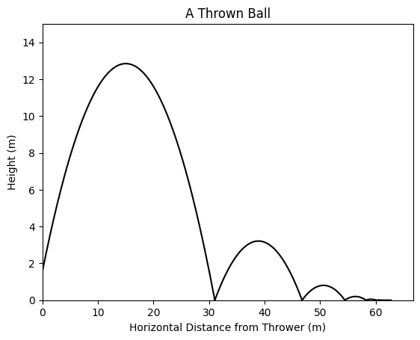

Using the graph, determine:

1. where on the graph the ball is thrown (circle it)
2. how far the ball traveled before hitting the ground: __________________
3. about how many times it bounced: _____________________
4. how far the ball was when it began to roll: _____________
5. how far the ball was thrown: _______________
6. how far away the ball was when it reached its highest point: ___________________

### 

### Chucking the ball extended

To the left are four graphs with ***time*** on the x-axis. Decide which graph goes with each of the following:

1. The height of the ball versus time: ___________
2. The distance from the thrower versus time. _____
3. The vertical velocity of the ball versus time: ______
4. The horizontal velocity of the ball versus time: ______

### Pollutant AQI

Wildfires can be dangerous for a lot of reasons. One of the reasons is that they emit harmful air pollutants into the air, for example PM2.5, fine particles that can negatively impact lunch functioning[1]. We want to understand how the pollution spreads in the surrounding environment from the *center* of the fire (not necessarily the edge). Governments often release a metric called the AQI (air quality index), a way of measuring the concentration of a pollutant in the air. The higher the AQI, the more of the pollutant there is and the more dangerous it is. Below is a chart of how harmful pollutants at each AQI are[2].

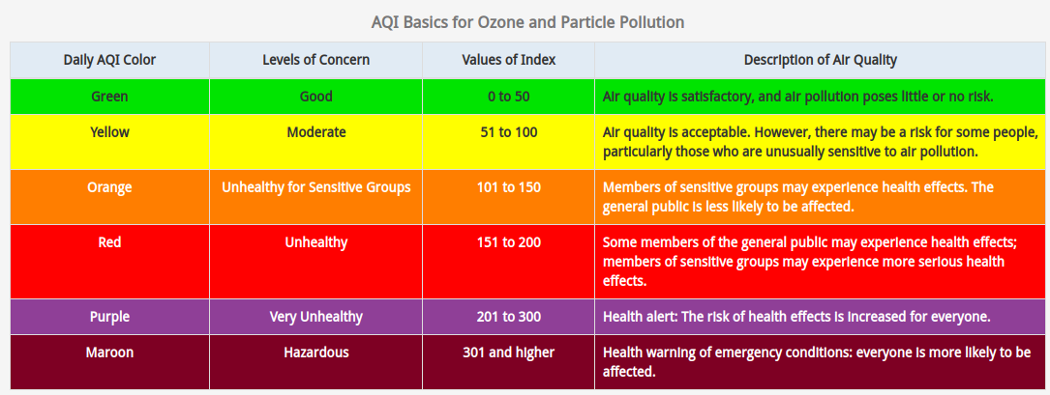

Image the AQI of PM2.5 in the air can be expressed as a quadratic function of the distance from the center of the fire. The graph is below. Answer the following questions about the graph

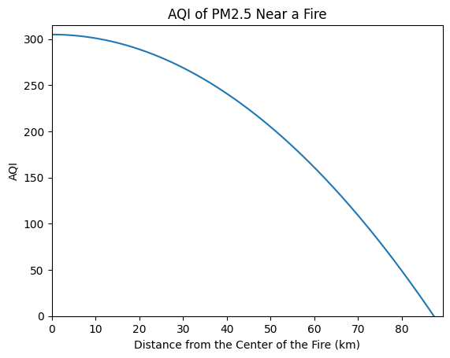

1. What does the x-intercept represent? The y-intercept?

2. About how far from the center of the fire would someone with asthma need to be in order to be safe ? How do you know?

3. About how far away from the center of the fire would you need to be so that the fire poses very little or no threat to you ? How do you know?

### An Ant Farm

Your older sister is going away to college and is leaving you with her ant farm. When she gives it to you, it turns out she hasn’t been taking great care of the ants. They seem to be dying faster than they are reproducing. Scared, you start measuring the ant population (via estimation) and giving them a special formula each day to help them live. The measurements over time can be seen below.

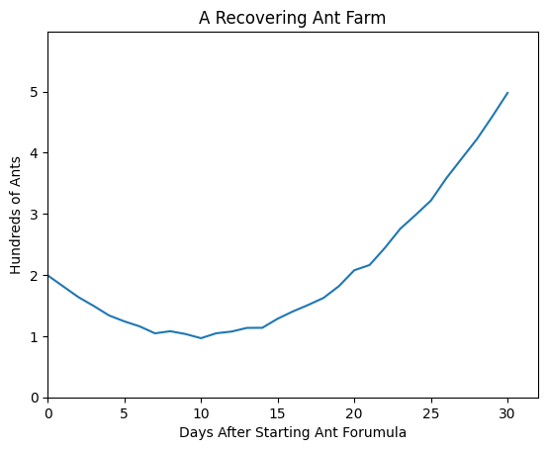

1. What’s the lowest point in the population? What part of the quadratic does that correspond to? After how long does it happen?

2 . Why do you think the ant population initially goes down?

3. Why do you think the lines are not perfectly straight?

4. You notice that it looks a lot like a quadratic. Write an *approximate* formula for the graph. Explain.

Remember that a quadratic form in vertex form can be written:

Where:

* the vertex occurs at (h, k)
* a is a factor of that tells how much the population grows with the formula

### The Parabolic Mirror

Did you know that the Olympic torch is traditionally lit with a mirror? How is that possible? Well, it’s not just any mirror, it’s a *parabolic mirror*, a mirror shaped like a parabola. See the pictures[3],[4] below.

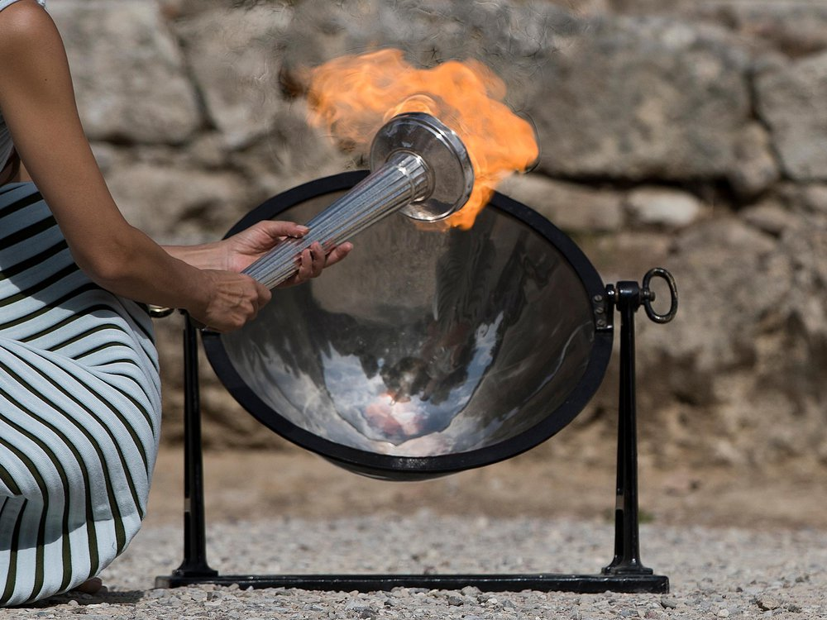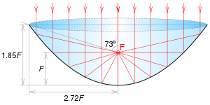

Parabolas have an important property called the *focal point*, and while exactly how this works is beyond the scope of our class, we can think of the *focal point* as the place where the incident light is most concentrated. So, if the sunlight enters the parabolic mirror, the *focal point* is where we will most feel the heat of the sun when the light is reflected back. If we locate our unlit torch at the *focal point* (F in the diagram above) of the mirror, the high intensity light will heat it up until it lights! Understanding the *focal point* of mirrors and lenses is part of the study of *optics*.

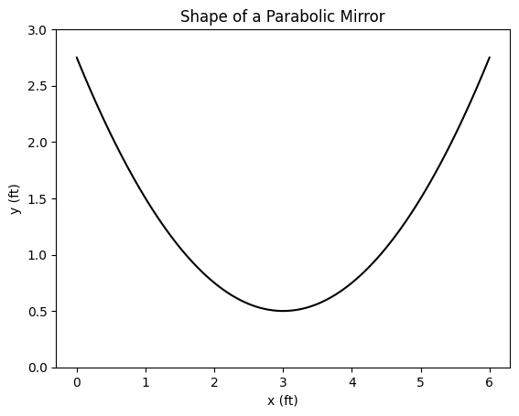

Now, imagine we have a lens with the shape of the lens to the right. With the following equation:

1. What are the coordinates of the *vertex* of our mirror?

2. The *focal point* can be found (known as the focal length) above the lowest point of the lens. Find the focal length of our parabolic mirror.

3. At what coordinate should the tip of the torch be held in order to light it? Draw it on the given graph and label it F.

1. Information from New York State Health Dept: https://www.health.ny.gov/environmental/indoors/air/pmq_a.htm#:~:text=Fine%20particulate%20matter%20(PM2.5,hazy%20when%20levels%20are%20elevated.
2. AQI information and graphic can be found here: https://www.airnow.gov/aqi/aqi-basics/
3. Image 1 from: <https://www.smithsonianmag.com/innovation/your-burning-questions-about-olympic-torch-answered-180968120/>
4. Image 2 from https://en.wikipedia.org/wiki/Parabolic_reflector